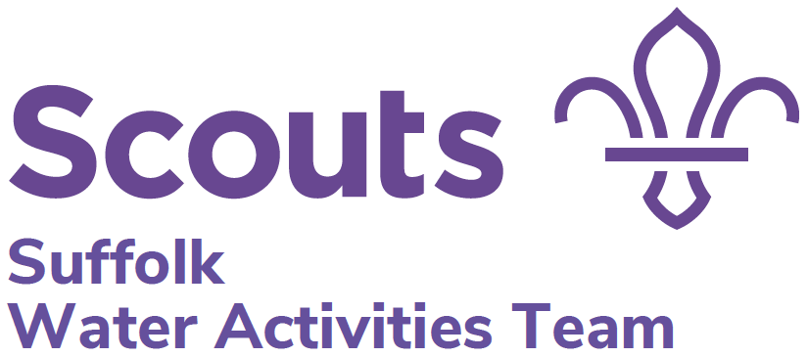

Thorpeness Meare Day

Saturday 27th Sept 2025
Boating fun and games for
Guides, Scouts, Rangers and Explorers
Leaders are very welcome but not essential.
(Come and join in the fun, sit and drink coffee or have a day off!)

Thorpeness Meare is a public boating lake, just north of Aldeburgh. The day’s activities include, free time boating around the Meare in the morning and various watery team games in the afternoon.
Cost is £15 per participant
Registration is at 9.30am and we will finish and sign out at 4pm.
Participants must be able to swim 50m in the appropriate clothing and have a consent form.
It can be cold, it will be wet and muddy so participants will need to dress suitably.
All participants will be expected to take part in all activities.
Any queries please contact: Jo Tel: 07885 265074
Send the application form to the County Office, 9 Brandeston Close, Great Waldingfield, Sudbury, CO10 0XY or e-mail gillian.smith44@btinternet.com and copy to: jsaagi@woodbridgeschool.org.uk.

Cheques payable to Suffolk Guide Association sent to County Office or BACs transfer to: Suffolk Guide Association, 30-13-64, 00022679.
Please reference clearly e.g. 1st Kesgrave Scouts use - 1stKesScTMD25

------------------------------------------------------------------------

Thorpeness Meare Day – 27th September 2025

Unit name _______________________________________________
Numbers are limited to 6 per unit. Number of places required. ___
I would like ______ extra places if possible (notification will happen in September)
Which evening of the week does your unit meet_________________
Cheque for £ enclosed or BACs transfer made for £______ reference____________
Contact name and address ______________________________________

__________________________________________________________

Email___________________________ Telephone number_____________

