Bury St Edmunds District Commissioner Team

Role Descriptions
Background
Bury St Edmunds is one of eight districts in Suffolk and has 12 Groups, 6 Explorer Units and 1 Network Group serving almost 550 young people and with an adult support of almost 250. The District is now seeking a new District Commissioner and newly created roles of Deputy District Commissioners to take the District forward to support and deliver the Skills For Life Strategy set out by the Scout Association.
Skills for Life
The 5-year (now 7 year due to Covid) strategy was launched in 2018 to support the mission of the Scout Association, namely “Scouting actively engages and supports young people in their personal development, empowering them to make a positive contribution to society. ​” The strategic vision of Skills for Life is “By 2023 we will have prepared more young people with skills for life, supported by amazing leaders delivering an inspiring programme.” ​Our vision is made up of four goals.
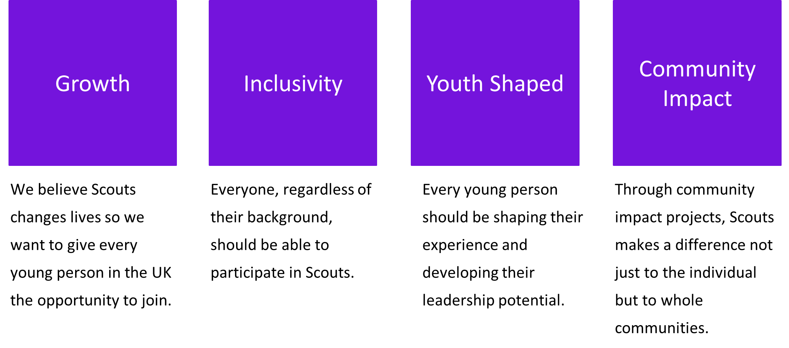
These goals will be delivered by four pillars of work namely:
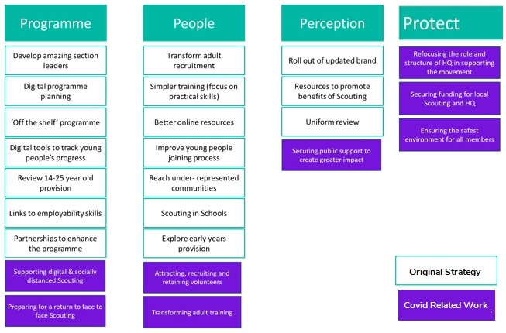

The new District team is aligned around these pillars to deliver more successful scouting to Bury St Edmunds.
District Commissioner
Outline Role Description

The district commissioner has overall responsibility for the district with particular emphasis on direction, strategy and ensuring that an excellent programme is in place for the District and within groups. Work with ADC section leaders to ensure that new ways for delivering programmes are shared and implemented across groups to top awards are earned by young people. This supports the Skills for Life work stream “Programme” - A fun, enjoyable, high quality programme consistently delivered​ and supported by simple (digital) tools.

Outline: To manage and support the Scout District to ensure it runs effectively and that Scouting within the District develops in accordance with the rules and policies of The Scout Association so that that the District provides good quality Scouting for young people and proactively supports and manages adults in the District.
Responsible to: County/Area Commissioner (or deputy if appropriate).
Responsible for: Deputy District Commissioners, Group Scout Leaders, District Explorer Scout Commissioner, District Scout Network Leaders, Assistant District Commissioners, District Scout Active Support Managers, District Scouters, District Advisers, Nights Away Advisers, District Media Development Manager.
Main contacts: County Commissioner/Area Commissioner/Region Commissioner (Scotland), Deputy District Commissioners, Group Scout Leaders, District Explorer Scout Commissioner, District Scout Active Support Managers, District Scout Network Leaders, Assistant District Commissioners, members of the District Executive Committee and its sub-committees, County/Area/Regional(Scotland) Scout Network Commissioner, , County/Area/Regional(Scotland) Training Manager, Local Training Manager, members of the Regional Development Service, Local Development Officers or Field Commissioner (as appropriate), other District Commissioners, members of the local community, schools and other youth organisations.
Appointment requirements: Must complete the relevant training (a wood badge) within three years of taking up the role. Must be eligible for charity trustee status (as a member of the District Executive Committee). It is expected that whilst volunteering for this role you will undertake regulated activity.
Main tasks:
• Ensure that the District thrives and has the best systems in place to support the Groups, to support all adult volunteers in the District and to develop Scouting in the District.
• Provide line management and support to the adults in the District that directly report to you including setting objectives for their work and holding regular reviews and one-to-one meetings.
• Produce a vision for the District and implement a development plan to meet that vision.
• Ensure that Scouting in the District is attractive to young people and adults from all backgrounds in the District.
• Ensure that the District has an adequate team of supported and appropriate adults working effectively together and with others to meet the Scouting needs of the area.
• Ensure that problems within the District are resolved so that excellent Scouting is provided to young people in the District.
• Work with the County/Area Commissioner and other District Commissioners in the County / Area to ensure that the Scouting in the County / Area thrives.
• Ensure safeguarding is managed in the district in accordance with POR.
Person specification
Knowledge and experience Essential/Desirable
Ability to manage adults effectively Essential
Understanding of the challenges of working in the voluntary sector Desirable
Experience of working with young people and/or community work with adult groups Desirable Experience of working in the Scout or Guide Movement as an adult Desirable Skills Essential/Desirable Excellent written and oral communication skills Essential Provide advice and guidance effectively to others Essential Provide inspirational leadership for the District Essential Provide strategic direction for the District Essential Motivate adults volunteering in the District Essential Build, maintain and facilitate effective working relationships with a wide range of people Essential Enable others to identify issues, clarify objectives, develop attainable objectives and gain the necessary skills and confidence to work as an effective team Essential Ability to negotiate compromises Essential Plan, manage and monitor own tasks and time Essential Construct and implement long-term plans that improve and expand the Scouting offered to young people and identify any training, resources and other needs required to undertake this work
Essential
Use basic computer software Essential

Personal qualities Essential/Desirable An understanding of the needs of adult volunteers Essential Flexible approach Essential Self-motivated Essential Able to work as part of a team and promote good teamwork Essential Resourceful, energetic and enthusiastic about the job Essential Acceptance of the fundamentals of the Scout Movement Essential
Detailed Description of the role

- Providing direction – as an effective District Commissioner you will be required to:
• Lead by example to promote a co-operative culture of working in the District.
• Create a vision for the future development of the District that takes into account the strategic objectives of The Scout Association and the plans for your County/Area.
• Develop a plan to realise the vision for the District, implement and regularly review it.
• Provide leadership, inspiration and motivation for all adults volunteering in the District.
• Ensure that everyone in the District follows the policies and rules of The Scout Association.
• Carry out regular one-to-one meetings and support adults who report directly to you.
- Working with people – as an effective District Commissioner you will be required to:
• Develop good working relationships based on trust and Scout values with the adults in the District
and with others in Scouting.
• Build a team spirit in the District and support the development of the team as a whole.
• Ensure that adults in the District perform to agreed standards and if serious problems occur, the
correct procedures are followed in consultation with the County Commissioner/Area
Commissioner/Region Commissioner (Scotland).
- Achieving results – as an effective District Commissioner you will be required to:
• Satisfactorily complete projects in the District for which you are responsible.
• Ensure that all the initiatives in the District are managed appropriately.
• Have a robust District development plan in place and regularly review progress.
- Enabling change – as an effective District Commissioner you will be required to:
• Support and encourage adults in the District to think of new and creative ways to improve the
District.
• Be enthusiastic about new ideas, give constructive feedback on those ideas and encourage and
support further work on them.
• Develop effective plans to implement change and then carry them out, working together with
relevant members of the District.
• Recognise the contribution of others towards change and improvement.
- Using resources – as an effective District Commissioner you will be required to:
• As part of the District Executive Committee, ensure that appropriate financial measures are in
place.
• Work with the District Executive Committee and Group Scout Leaders to ensure that Scouting in
the District is safe.
• Work with the District Executive Committee and the District Team to ensure that the District has
sufficient physical resources to support its work with youth members.
• Work with the District Executive Committee and the District Team to minimise the negative
impact and maximise the positive impact that the District has on the environment.
• Make decisions about matters within the District based on the best available information.
- Managing your time and personal skills – as an effective District Commissioner you will be
required to:
• Agree realistic goals and targets with the County Commissioner/Area Commissioner/Region Commissioner (Scotland) for the development of the District that work towards The Scout Association’s strategic objectives.
• Consider the future requirements of your role then identify the skills and knowledge that you need to develop or improve and the steps you will follow to do so.
• Regularly check how you use your time and identify possible improvements so that you focus on the goals and priorities that you have agreed with the County Commissioner/Area Commissioner/Region Commissioner (Scotland).
• Ask other adult volunteers for feedback about how you carry out your role and act on it.
• Attend National, Regional and County/Area meetings, workshops and events.

